# **Salesforce Project: FitTrack – Health & Fitness CRM**

**Industry:** Fitness & Health  
**Project Type:** B2C Salesforce CRM Implementation  
**Target Users:** Gym Admin, Trainers, Members

**Problem Statement:** Most gyms manage members, trainers, and workout plans manually using spreadsheets or paper records. This results in:

* Difficulty tracking active/expired memberships
* Inefficient trainer assignment
* Delayed communication with members
* Poor reporting for management

**FitTrack Solution:** A Salesforce-based Health & Fitness CRM to automate member management, trainer assignment, workout plans, reporting, and notifications.

## **Phase 1: Problem Understanding & Industry Analysis**

**1. Requirement Gathering:**

* Member management (Name, Email, Phone, Membership dates, Fitness goals)
* Trainer management (Name, Expertise, Assigned Members)
* Workout plan management (Name, Duration, Intensity, Assigned Member)
* Dashboard and reporting (Active vs Expired members, Trainer workload)
* Automated notifications for membership expiry or workout plan updates

**2. Stakeholder Analysis:**

* **Admin:** Full control over members, trainers, and dashboard monitoring
* **Trainer:** Track assigned members, update workout plans, receive notifications
* **Receptionist (optional):** Add new members, manage basic member data
* **Member:** View personal membership and progress (optional, external portal possible)

**3. Business Process Mapping:**

1. Member signs up → added to CRM
2. Assign membership start/end dates → track membership status
3. Assign trainer to member → create workout plan
4. Daily/weekly updates on workouts → progress tracking
5. Generate reports → dashboards for active/expired members

**4. Use Case Analysis:**

* Manual tracking leads to errors, missed follow-ups, and unoptimized trainer workload
* Management cannot see real-time member progress or trainer efficiency

**5. AppExchange Exploration:**

* Checked apps like **MyFitnessPal for Salesforce** and **Health Cloud Lite** for reference features

## **Phase 2: Org Setup & Configuration**

**Purpose:** Configure Salesforce org for FitTrack to ensure users, profiles, roles, and security settings are correct.

**Steps:**

1. **Salesforce Edition:** Developer Edition
2. **Company Profile Setup:** Name, Address, Timezone, Locale, Currency

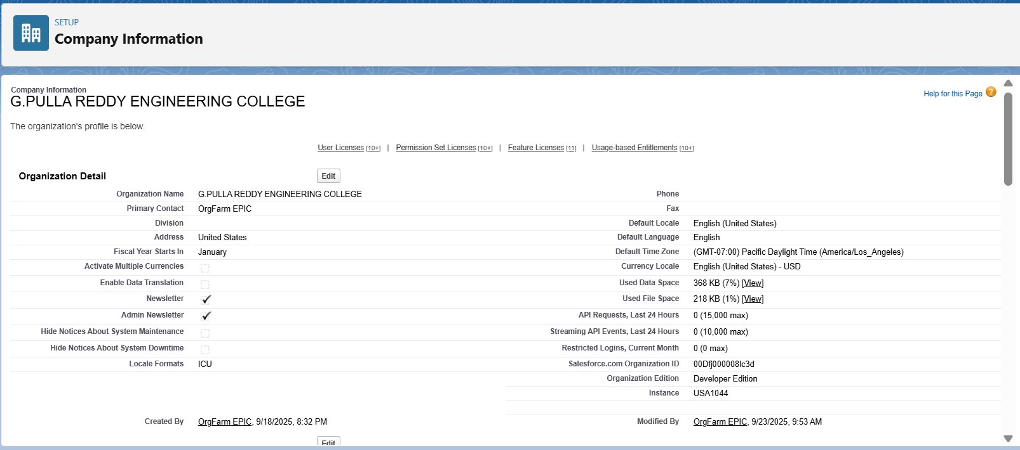

1. **Business Hours & Holidays:** Mon–Sun, 6 AM – 10 PM; add public holidays
2. **Fiscal Year:** Standard
3. **User Setup & Licenses:** Create sample users:  
   * Admin (Full access)
   * Trainer (Manage Members & Workout Plans)
   * Receptionist (Member creation only)

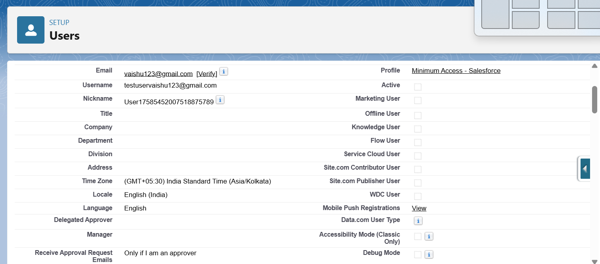

1. **Profiles:**
   * Admin → Full access
   * Trainer → Edit/View Members & Workout Plans
   * Receptionist → Create/View Members only
2. **Roles:** Admin > Trainer > Receptionist

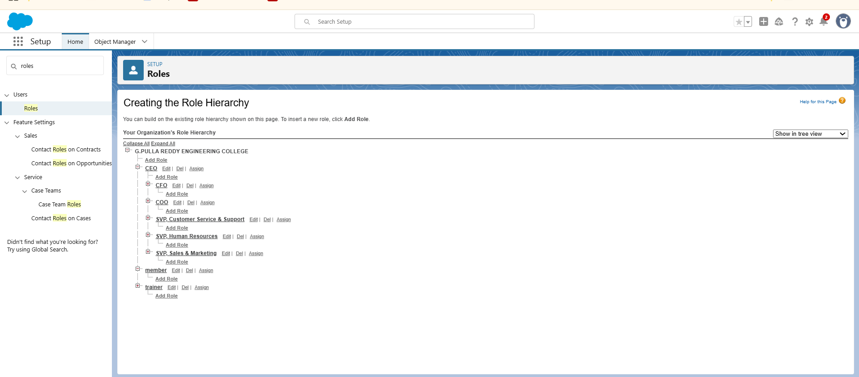

1. **Permission Sets:** Assign dashboard/report access for Trainers
2. **OWD & Sharing Rules:**
   * Members → Private
   * Trainers → Private
   * Workout Plans → Private
   * Sharing rules → Share members with their assigned trainers
3. **Login Access Policies:** Admin can login as any user
4. **Sandbox Usage & Deployment Basics:** Optional for larger org setup

## **Phase 3: Data Modeling & Relationships**

**Purpose:** Design objects and relationships for member, trainer, and workout data.

**Custom Objects:**

* **Member:** Name, Email, Phone, Membership Start/End, Fitness Goal, Age, Gender
* **Trainer:** Name, Email, Phone, Expertise
* **Workout Plan:** Plan Name, Duration, Intensity, Assigned Member

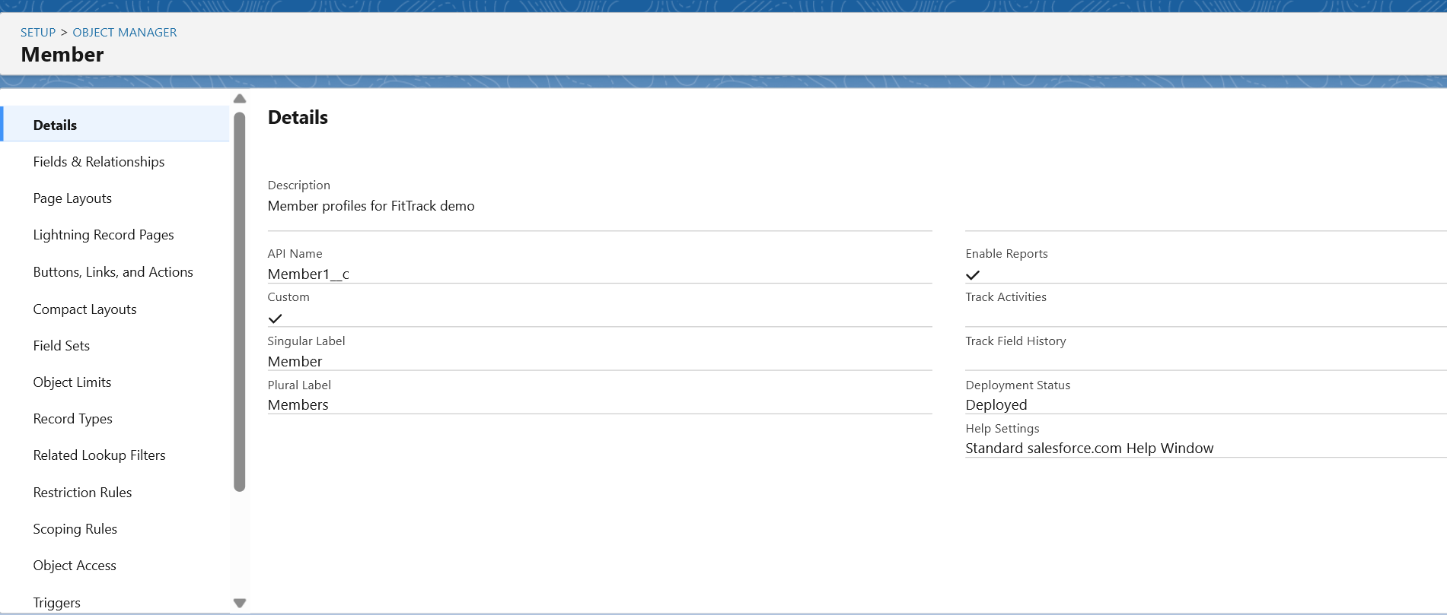

**Relationships:**

* Member ↔ Trainer → Lookup relationship (each member has a trainer)
* Member ↔ Workout Plan → Master-Detail (one member can have multiple plans)

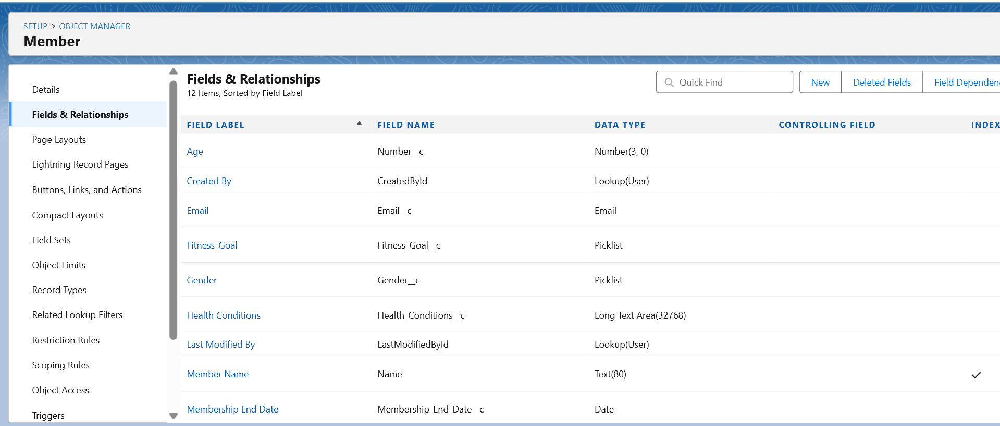

**Additional Configuration:**

* **Page Layouts:** Display key fields on Member, Trainer, Workout Plan
* **Compact Layouts:** Show Name, Membership Status, Fitness Goal
* **Schema Builder:** Visual diagram of objects and relationships

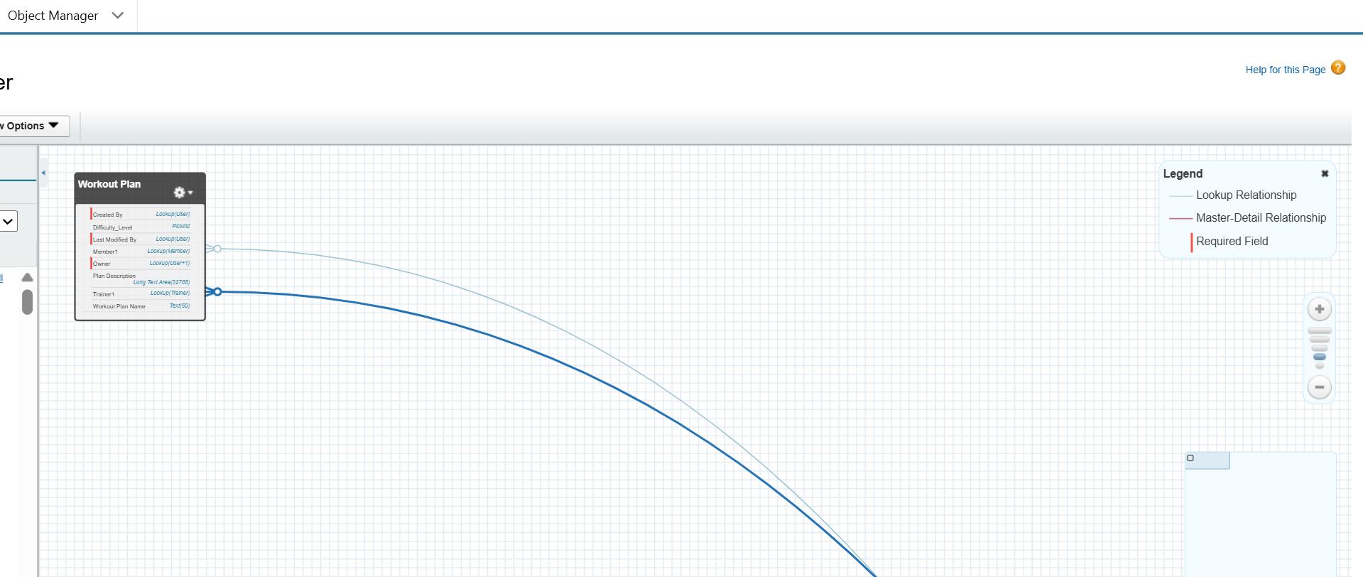

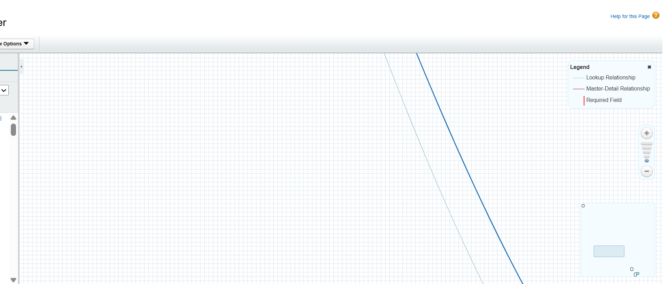

## **Phase 4: Process Automation (Admin)**

**Purpose:** Automate repetitive tasks and notifications.

**Automation Examples:**

1. **Validation Rules:** Ensure Membership End Date > Start Date

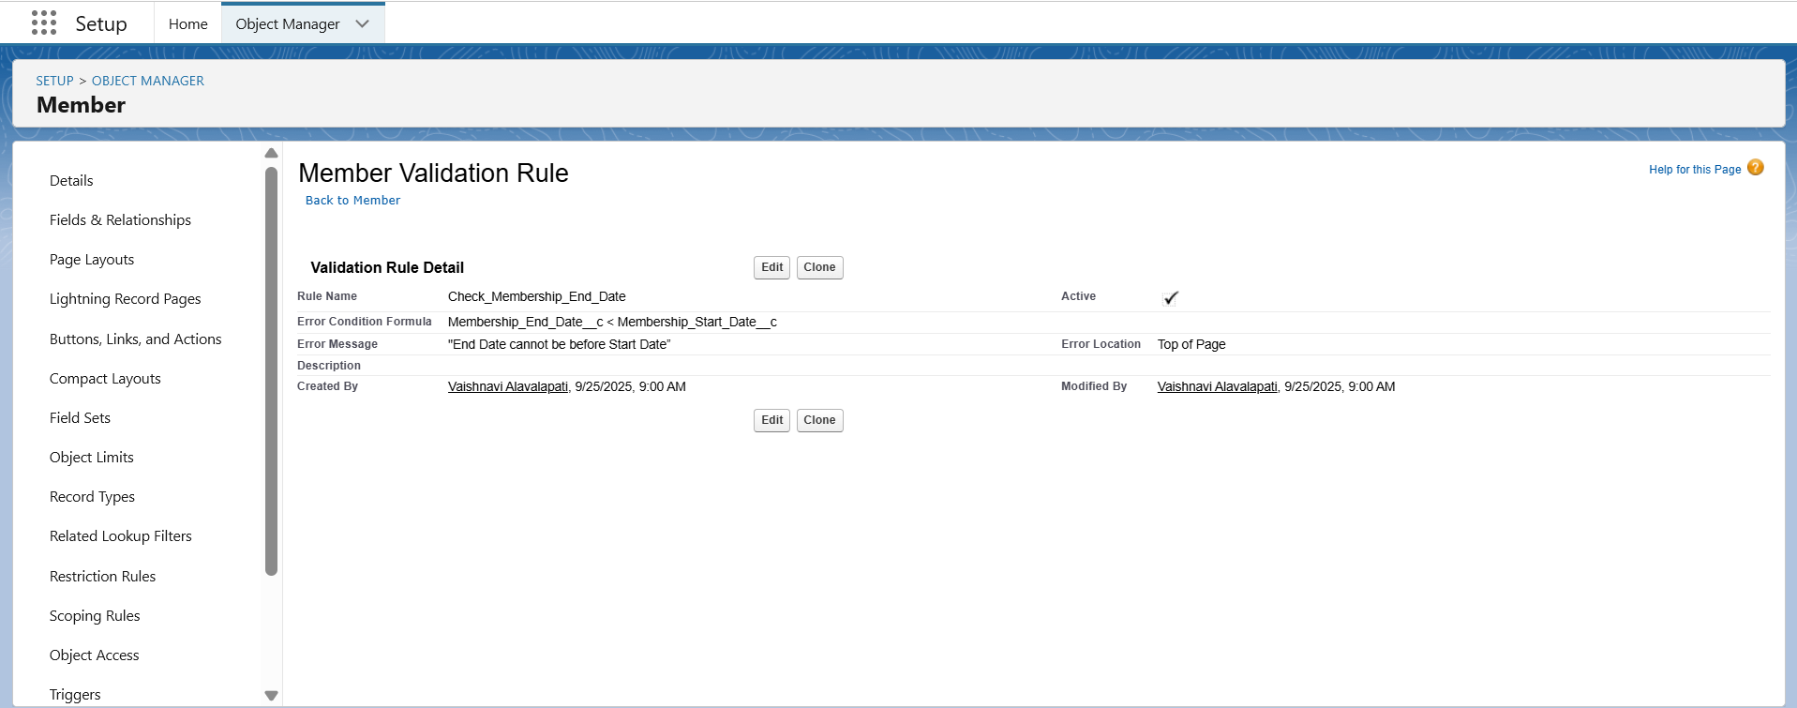

1. **Workflow / Process Builder:**
   * Notify Admin/Trainer when membership is near expiry
   * Auto-assign new members to default trainer if none chosen
2. **Flow Builder:**
   * Auto-create “Expired Members” report
   * Automate follow-up reminders

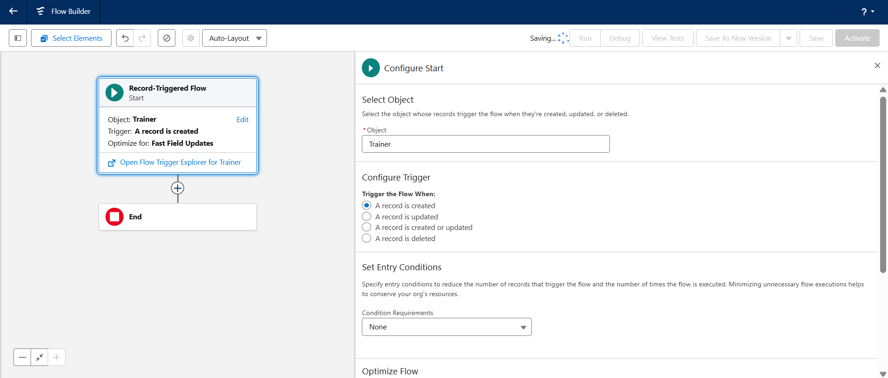

1. **Email Alerts / Custom Notifications:**
   * Notify members of upcoming expiry or trainer updates

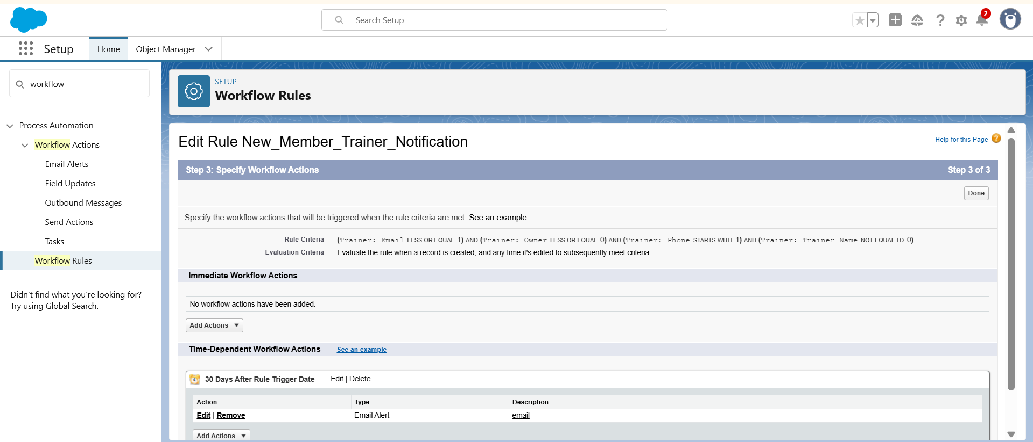

## **Phase 5: Apex Programming (Developer)**

**Purpose:** Use Apex code for advanced automation beyond clicks.

**Examples:**

* **Triggers:**
  + Member Insert → Assign default trainer
  + Workout Plan Update → Notify trainer
* **Helper Classes:** Calculate membership status (Active/Expired)
* **Batch Apex / Queueable Apex:** Bulk update expired members
* **Test Classes:** For triggers and classes to meet Salesforce requirements

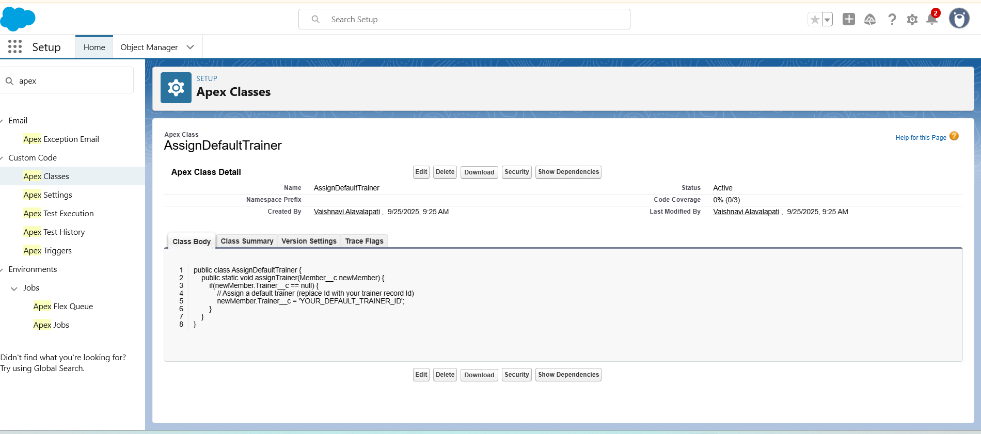

## **Phase 6: User Interface Development**

**Purpose:** Create a user-friendly experience for different roles.

**Steps:**

* Create **FitTrack App** in Lightning App Builder

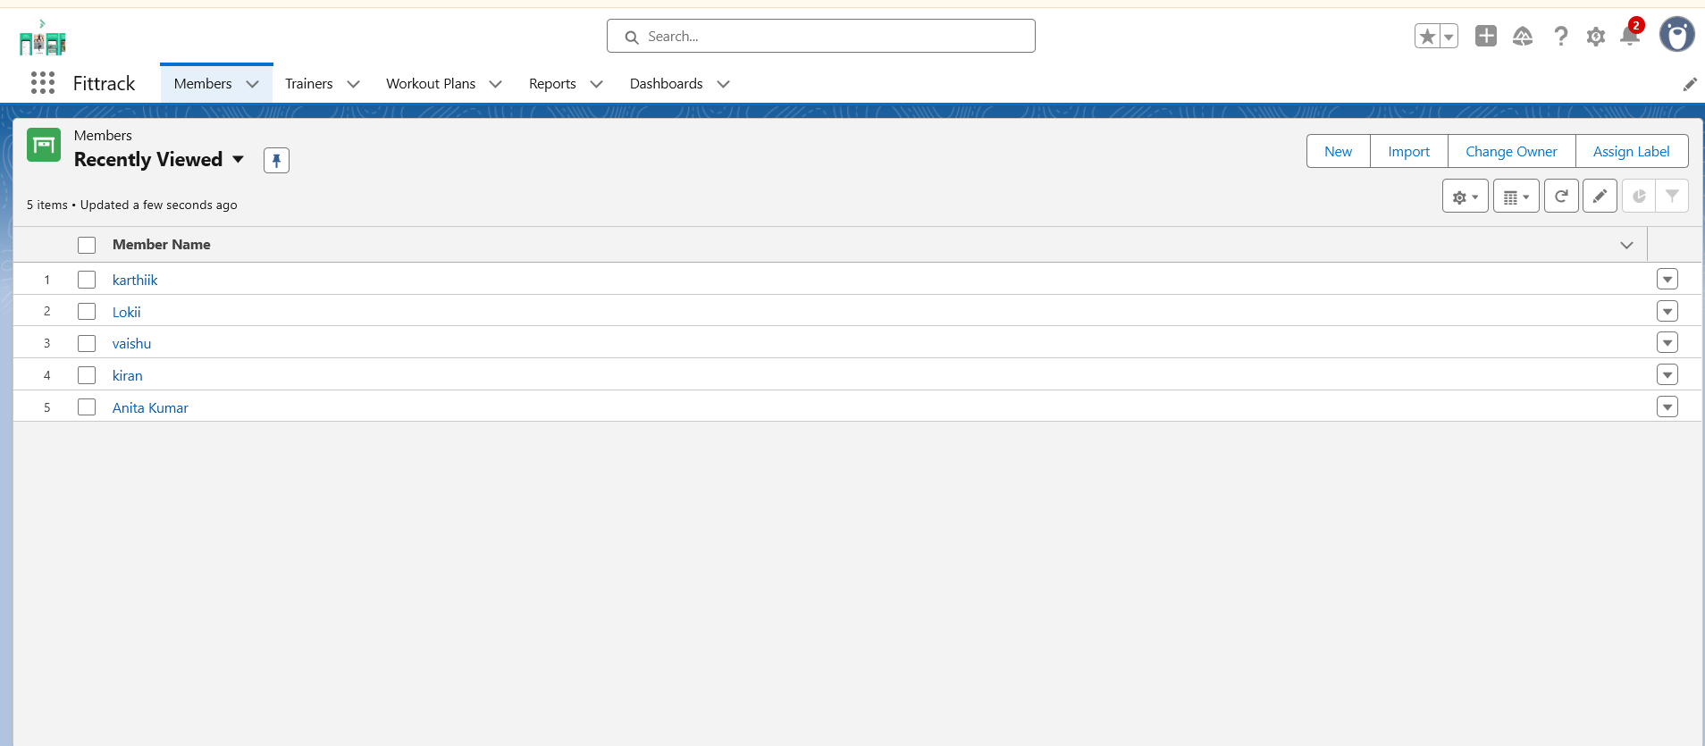

* Add Tabs: Members, Trainers, Workout Plans, Reports, Dashboards
* Customize **Record Pages** for Members and Workout Plans
* Home Page Layouts: Dashboard showing Active vs Expired Members, Trainer workload
* Optional: Lightning Web Component for member search or fitness progress chart

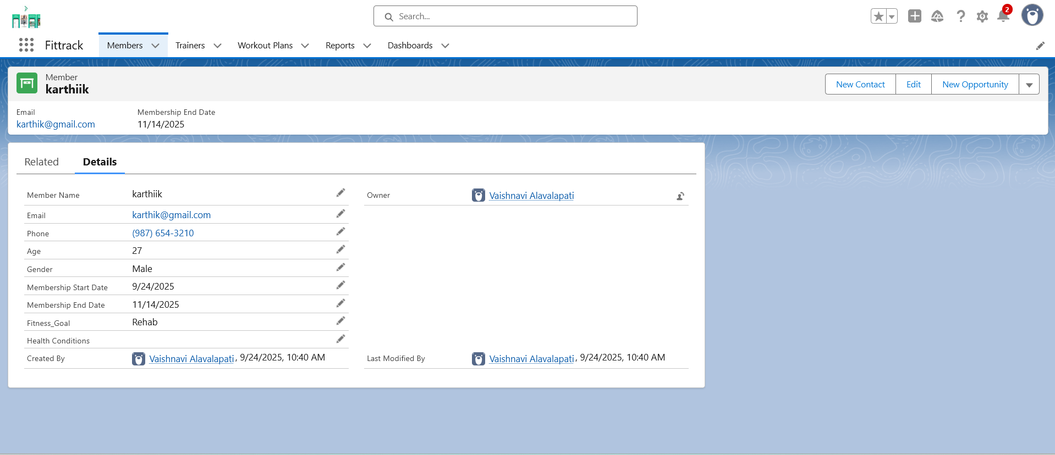

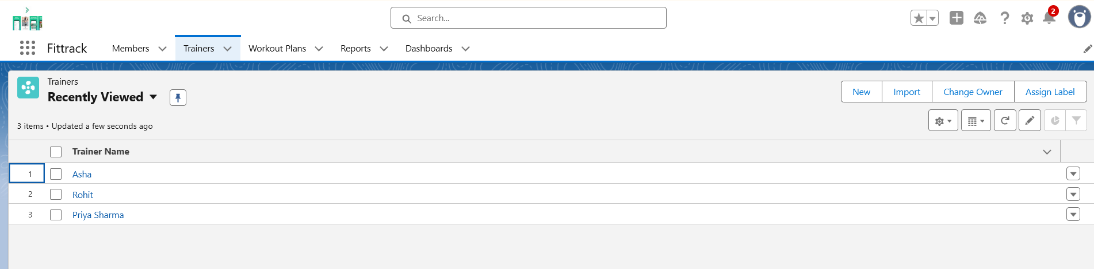

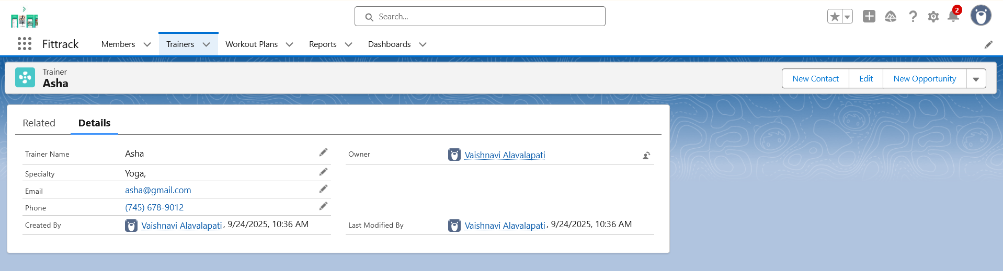

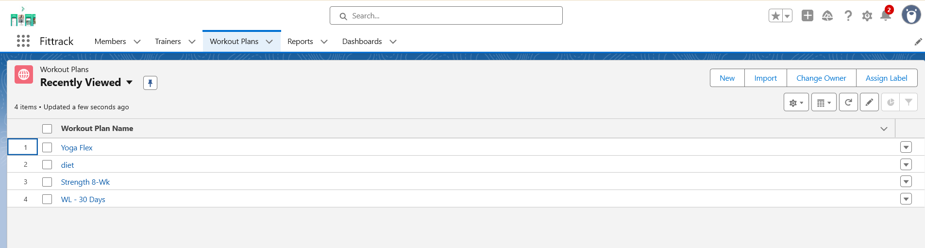

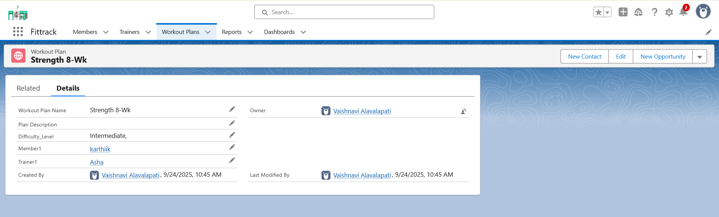

## **Phase 7: Integration & External Access**

**Purpose:** Connect Salesforce with external systems (optional).

* **Named Credentials:** Connect with third-party APIs (fitness trackers, email, SMS)

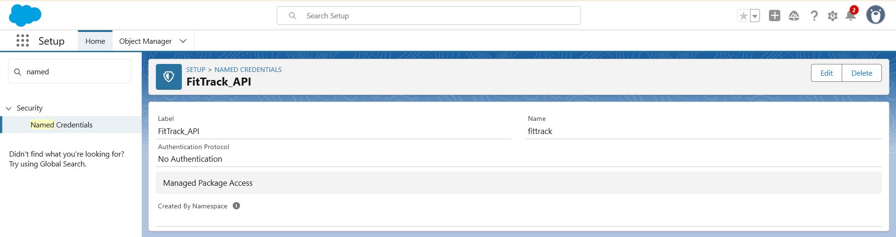

* **Platform Events:** Notify trainer when workout plan updated
* **Remote Site Settings:** Allow external API access

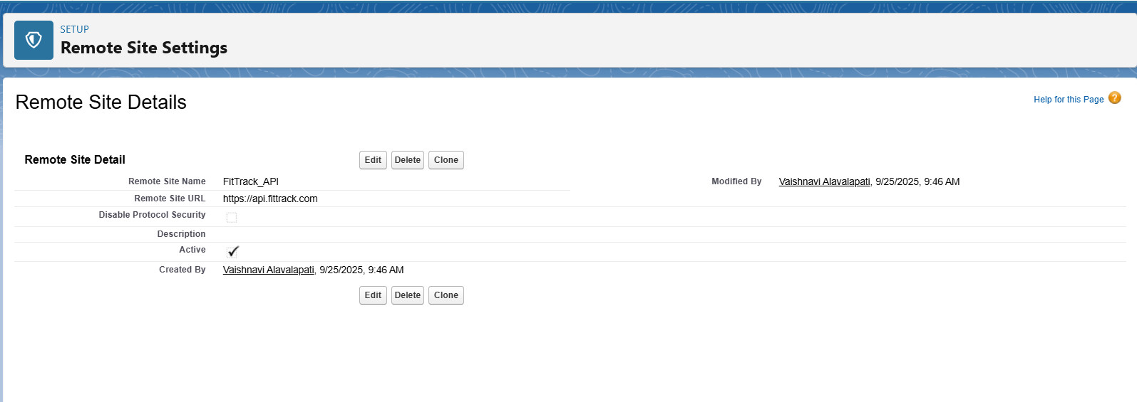

## **Phase 8: Data Management & Deployment**

**Purpose:**

To manage **data integrity**, ensure **smooth migrations**, and support **deployment between environments**. This phase ensures FitTrack’s **Members, Trainers, and Workout Plans** are uploaded, validated, and kept secure with proper backups.

## **1. Data Import Wizard (UI-based import)**

**Use Case in FitTrack:**

* Upload small datasets like sample **Members**, **Trainers**, or **Workout Plans**.
* Useful for initial testing.

**Steps:**

1. Go to **App Launcher** → search **Data Import Wizard**.
2. Scroll down to **Custom Objects** → Select **Member** object.
3. Click **Launch Wizard**.
4. Upload a CSV file (e.g., Member Name, Email, Fitness Goal, Start Date).
5. Map fields between CSV and Salesforce fields.
6. Click **Start Import** → records get uploaded.

## **2. Data Loader (Bulk Import/Export)**

**Use Case in FitTrack:**

* Upload large datasets (e.g., 500+ Members at once).
* Perform **Update** or **Delete** operations in bulk.

**Steps:**

1. From Salesforce **Setup** → search **Data Loader** → Download & install.
2. Open Data Loader → Log in with Salesforce credentials.
3. Choose operation: **Insert, Update, Upsert, Delete, Export**.
4. For example, choose **Insert → Member** object.
5. Upload CSV → Map fields → Run.
6. Records will be added to Salesforce.

## **3. Duplicate Rules (Data Quality Control)**

**Use Case in FitTrack:**

* Prevent duplicate **Member records** (same email or phone).
* Example: A person signs up twice with the same email.

**Steps:**

1. Go to **Setup** → search **Duplicate Rules**.
2. Click **New Rule** → choose **Member** object.
3. Define rule: Check if **Email** is the same.
4. Action: Allow with alert OR Block completely.
5. Save & Activate.

## **4. Change Sets / Deployment**

**Use Case in FitTrack:**

* Move **custom objects, fields, validation rules, reports, dashboards** from **sandbox** → **production org**.

**Steps:**

1. Go to **Setup** → search **Outbound Change Sets**.
2. Create a new Change Set → Name: “FitTrack Deployment”.
3. Add Components: (Member Object, Trainer Object, Reports, Dashboard).
4. Upload Change Set → Target Org.
5. In target org → approve & deploy.

## **5. Export / Backup**

**Use Case in FitTrack:**

* Monthly backup of **Member & Trainer data** for safety.
* Helps in recovery if data is lost or corrupted.

**Steps:**

1. Go to **Setup** → search **Data Export**.
2. Choose objects: **Member**, **Trainer**, **Workout Plan**.
3. Select frequency: **Monthly Export**.
4. Salesforce will generate a ZIP file with CSVs → Download.

## **Phase 9: Reporting, Dashboards & Security Review**

**Purpose:** Track member activity and performance metrics.

**Reports:**

* Active vs Expired Members (Matrix or Summary)
* Members by Fitness Goal (Summary)
* Trainer Workload (Tabular)

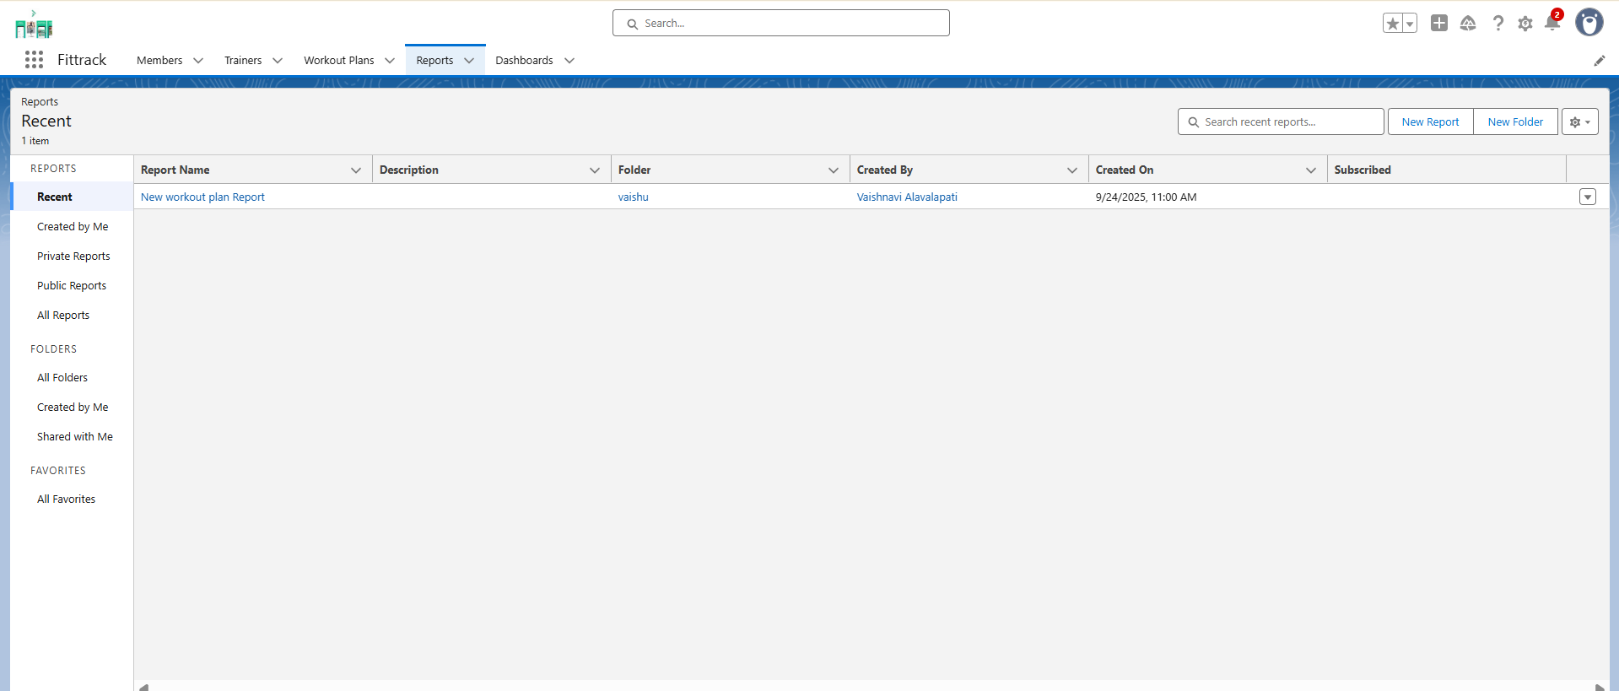

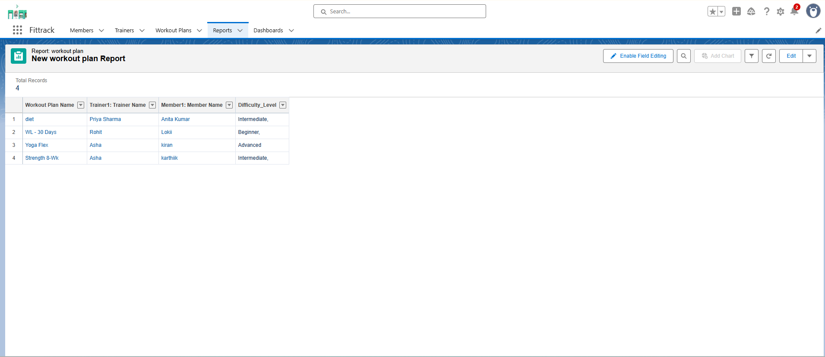

**Dashboards:**

* Donut chart – Active vs Expired Members
* Bar chart – Members per Trainer

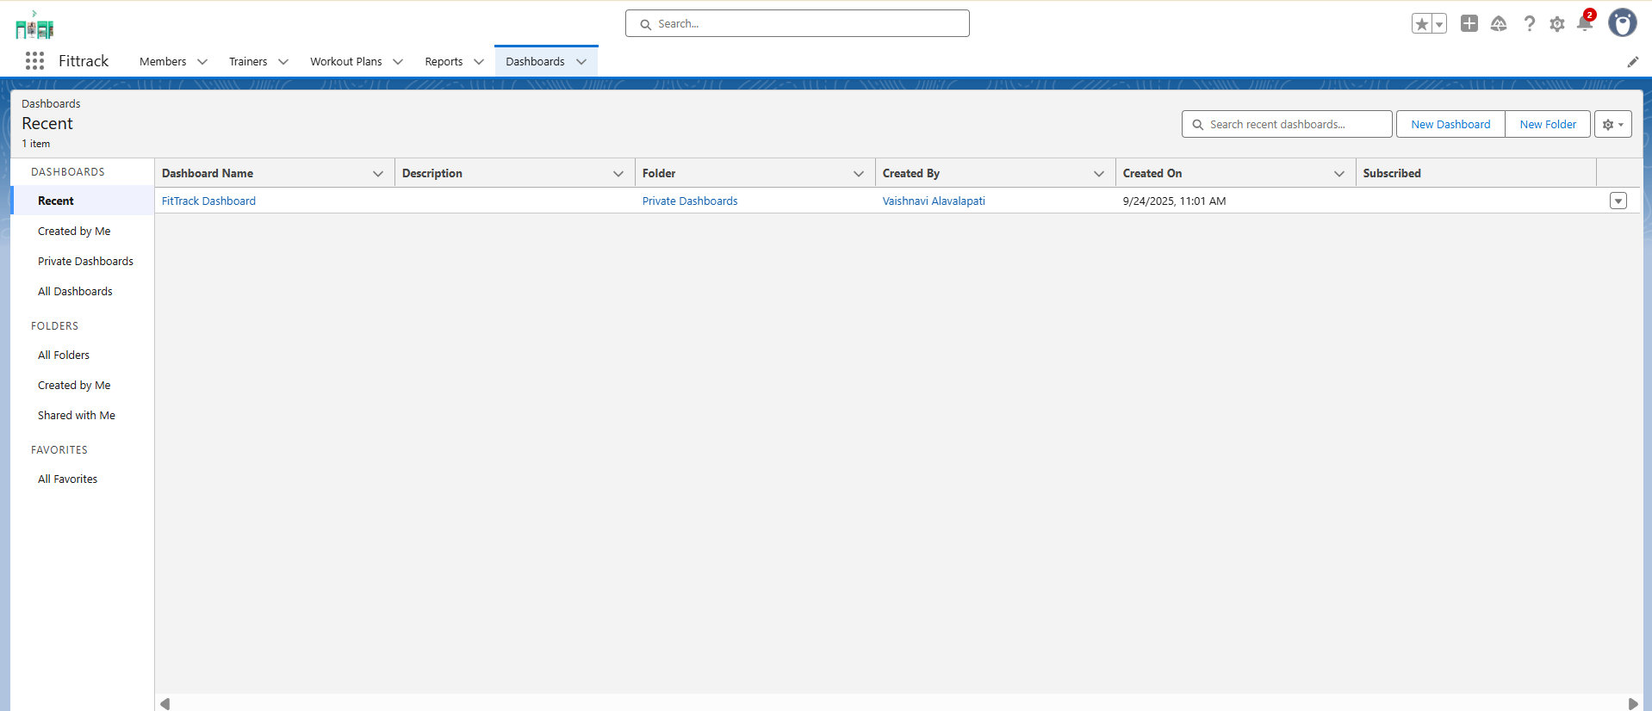

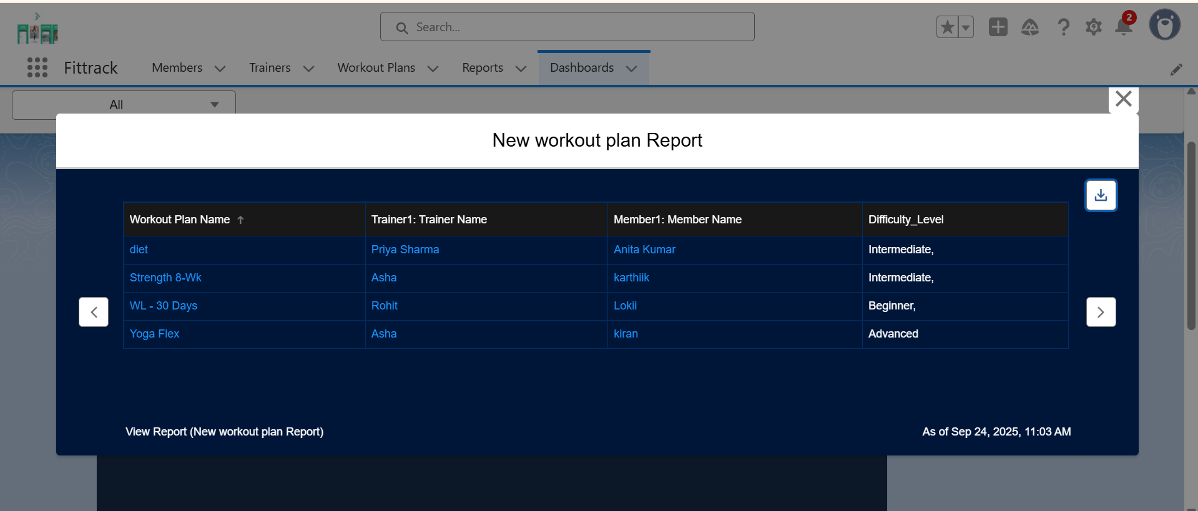

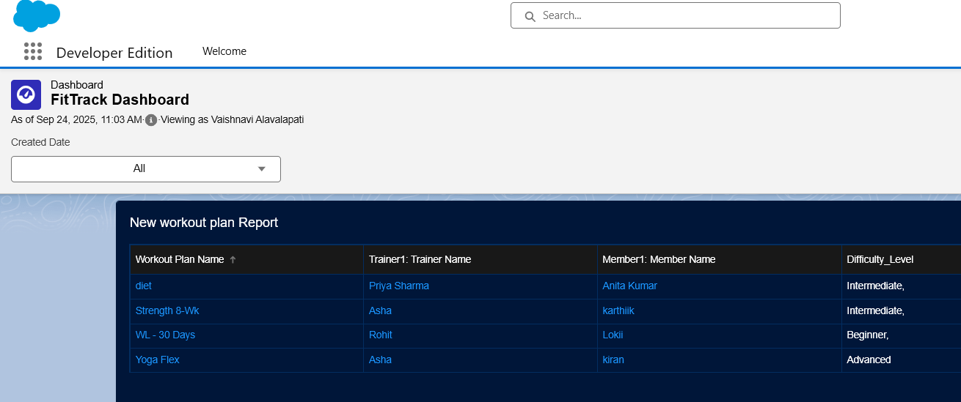

**Security:**

* Field-Level Security for sensitive data (Email, Phone)
* Sharing Rules applied
* Audit Trail for changes

## **Phase 10: Final Presentation & Demo Day**

**Purpose:** Showcase the project.

* **Pitch:** Explain problem, solution, and FitTrack features
* **Demo Walkthrough:**
  1. Create new member
  2. Assign trainer
  3. Create workout plan
  4. Show dashboards (Active vs Expired Members, Trainer workload)
* **Feedback Collection:** From mentor or peers
* **Handoff Documentation:** Include project report, screenshots, and GitHub repo
* **Portfolio Showcase:** Add to LinkedIn or resume

